**NAME---HARSH KUMAR**

**ID---B219027**

**BRANCH---CE-4TH SEM.**

**DATE--- 22-01-2021**

LAB-1

(**1**) **Inserting all records from another relation**

Example1:-

code:-

CREATE TABLE CUSTOMER1(CNAME varchar(255), CID int, ITEMNAME varchar(255),PRICE int);  
INSERT INTO CUSTOMER1(CNAME,CID,ITEMNAME,PRICE) VALUES('Somen Isco','699','LAPTOP','70000');  
INSERT INTO CUSTOMER1 SELECT CNAME,CID,ITEMNAME,PRICE FROM customer WHERE CNAME="Dhruv Rathee";  
SELECT * FROM rdbms_lab.customer1;

Old table from which copied values

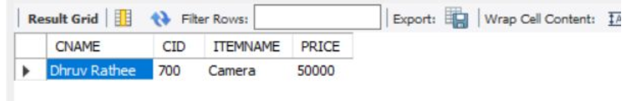

New table with copied values:

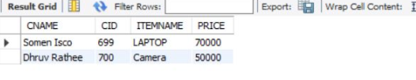

j

Example 2:-

Code:-

CREATE TABLE FACULTIES1(FNAME varchar(255),DEPT varchar(255),DESGN varchar(255));  
INSERT INTO FACULTIES1(FNAME,DEPT,DESGN) VALUES('Satya King','IT','web developer');  
INSERT INTO FACULTIES1 SELECT FNAME,DEPT FROM FACULTIES WHERE FNAME="A Kalam";

Updated Table:-

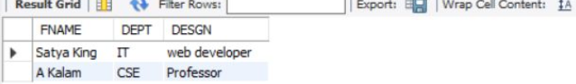

**(2) UPDATE-SET-WHERE**: used to update the content of a

record in a relation.

Example1:-

code:

-UPDATE students SET SNAME = 'nage' WHERE

ROLL='B1112';

Old table:-

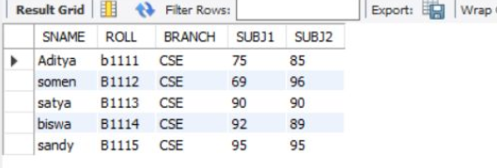table

New table:-

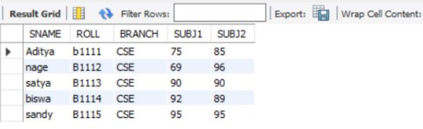

Example 2:-

code:-

UPDATE students SET SNAME = 'somen' WHERE

ROLL='B1115';

Old table:-

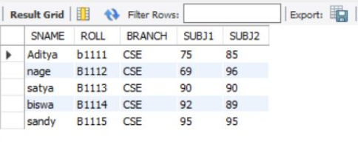

New table:

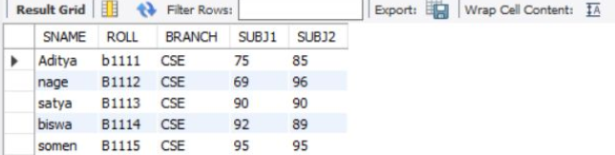.

**(​4​) SELECT :** display all fields for all records.

Example1:-

code:-

SELECT * FROM students;

Table:-

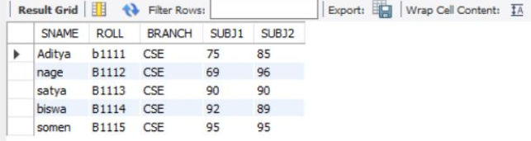

Example2:-

code:-

​SELECT * FROM college;

Table:-

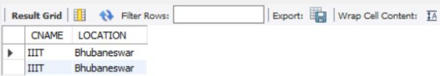

**(​5​) SELECT FROM:** To display a set of fields for all records of relation.

Example1:-

code:-​

SELECT SNAME, ROLL FROM students;

Table:

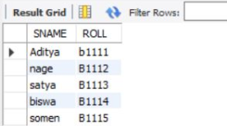

Example2:-

code:-

​SELECT CNAME FROM college;

Table:-

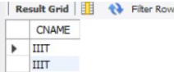

**(​6​) SELECT - FROM -WHERE:** This query is used to display a

selected set of fields for a selected set of

records of a relation.

Example1:-

code:-

​SELECT * FROM students WHERE SUBJ1>=90;

Table:-

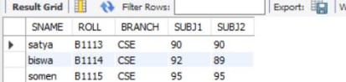

Example2:-

code:-​

SELECT * FROM college WHERE LOCATION='Bhubaneswar';

Table:

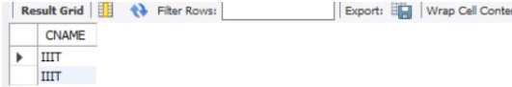

**(3) DELETE-FROM:** This is used to delete all the records of a relation

but it will retain the structure of

that relation.

Example1:-

code:-​

DELETE FROM customer1;

Old table:-

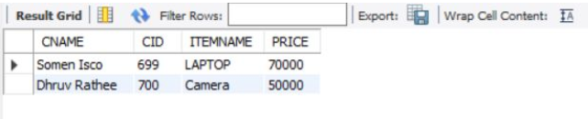

New table:-

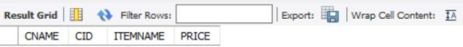

Example2:-

code:-​

DELETE FROM faculties1;

Old table:-

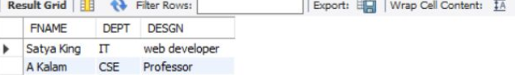

New table:-

